Store Header

Settings

Product Management

Add Product

Edit Product

Archive

Catalog

# Store Header

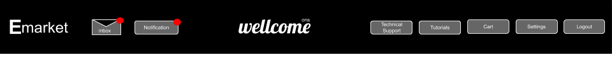

# Settings

# 

# 

# 

# 

# Products Management

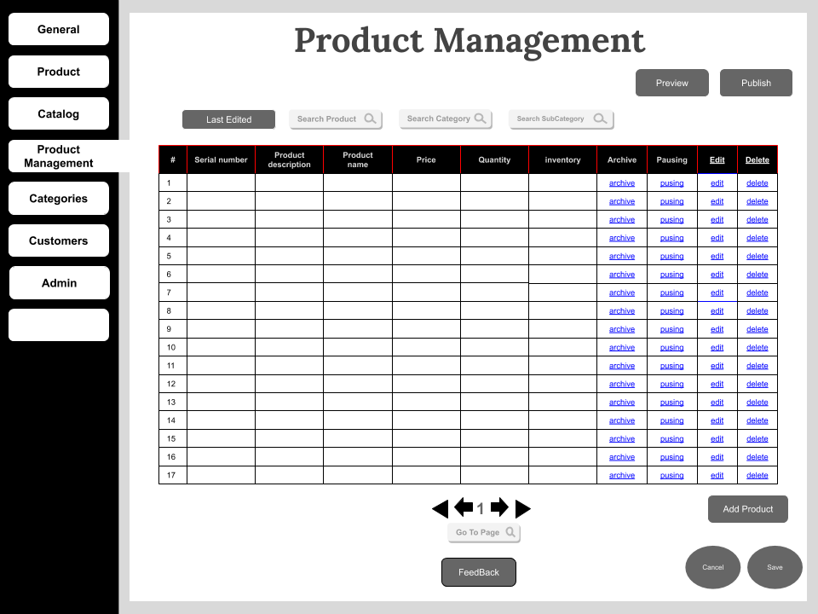

# Add Product

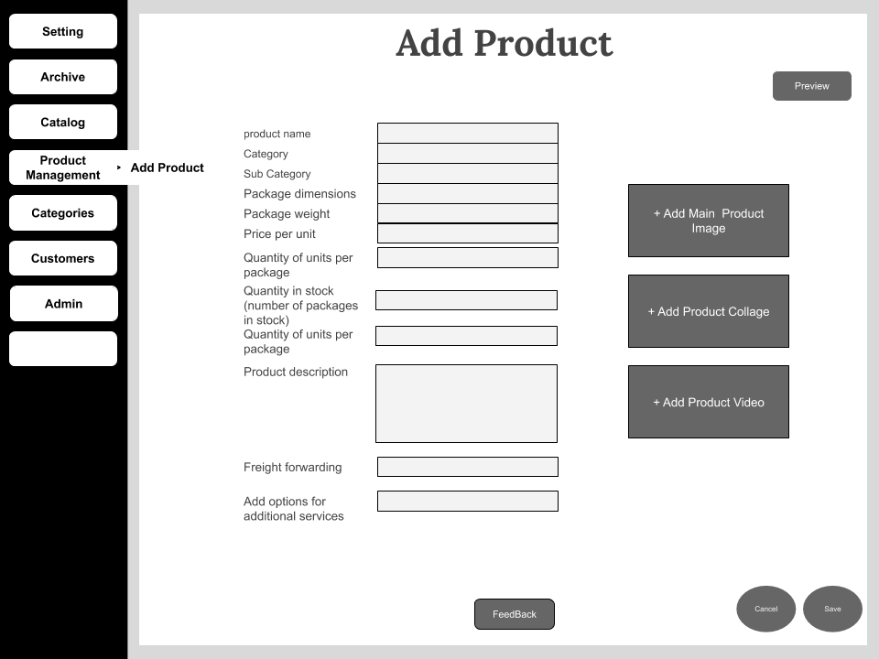

# Edit Product

# 

# 

# Archive

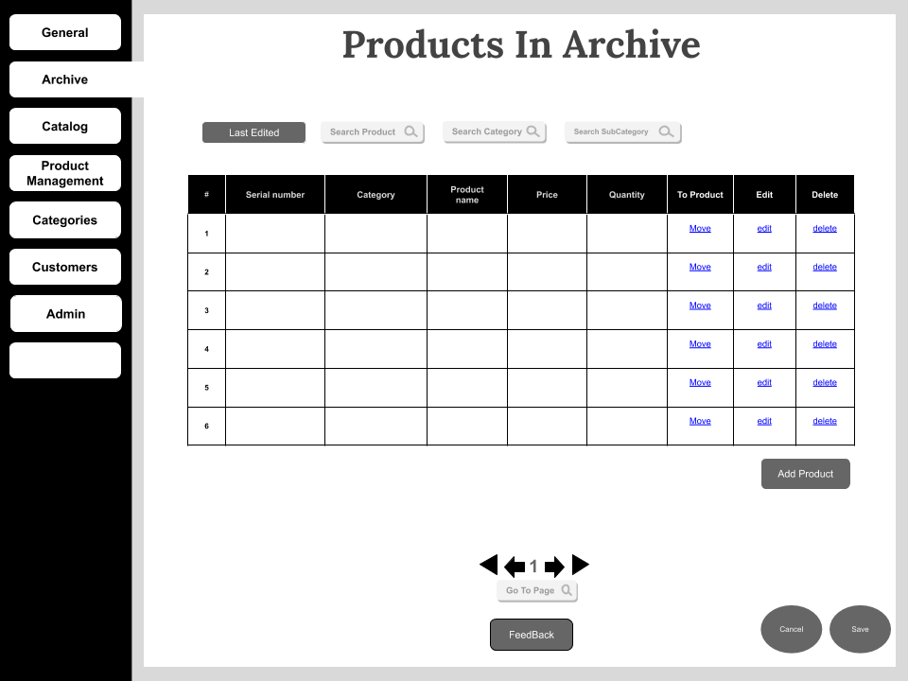

# Catalog

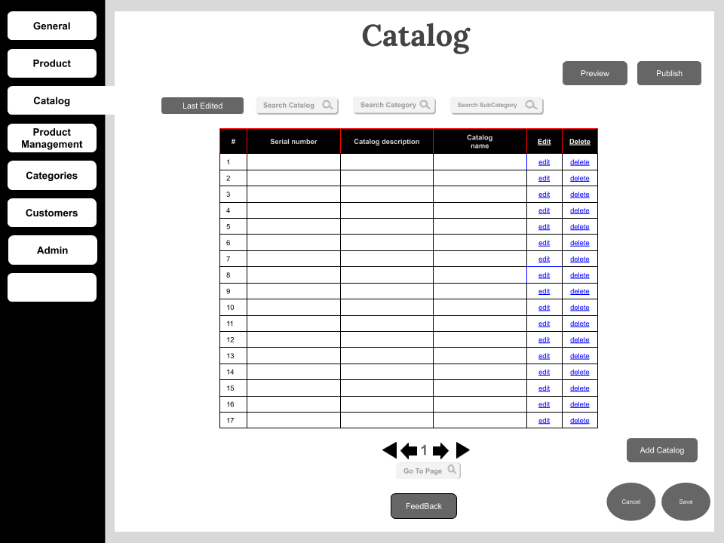

# Categories



# Customers

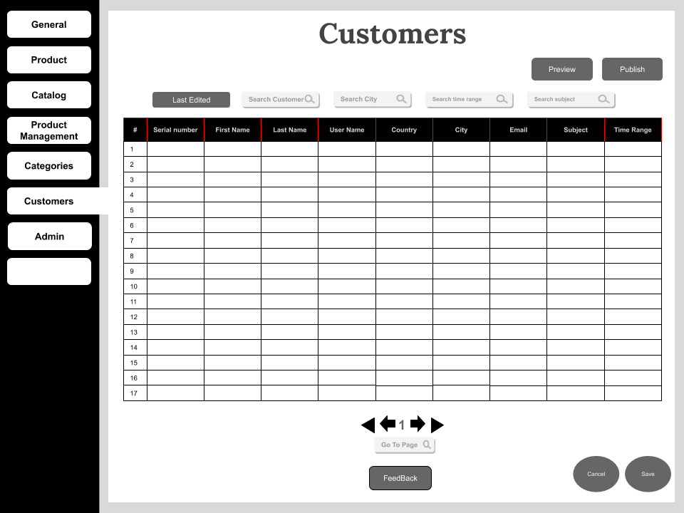

# Admin

